Case Report

Enhancing the stability of mandibular complete denture with neutral zone technique – a case report
¹Dr Sanjay Lagdive, ²Dr Rupal shah, ³Dr Himanshu Vadher

1. Professor , Department of Prosthodontics & Crown & Bridge
2. Professor & Head , Department of Prosthodontics & Crown & Bridge
QR Code: Scan Here
3. Post-graduate student, Department of Prosthodontics & Crown & Bridge
Dept of Prosthodontics, Govt Dental College and Hospital , Ahmedabad ,Gujarat
Corresponding author: Dr Himanshu Vadher

Abstract:
Conventional complete denture therapy for patients with severe residual ridge resorption is challenging. Because these patients suffer ongoing diminution of the denture foundation, modern approaches often involve dental implant therapy as a means of improving the denture foundation and supplementing the mechanics of prosthesis support, retention and stability. This article presents historical perspectives on the arrangement of denture teeth in the facial-lingual dimension and the contouring of complete denture polished surfaces. Additionally, a modern clinical technique is presented for the physiologic registration of denture tooth positions and denture base contours. Information gained may then be incorporated into definitive prostheses in an effort to achieve successful complete denture therapy.
Introduction
The basic objectives of Complete Denture Prosthodontics are the restoration of function, facial appearance and the maintenance of patient’s health. Loss of teeth leads to multi factorial changes occurring in the mouth like alveolar ridge resorption, expansion of the tongue, and laxity of muscles of face.²
when the natural teeth are lost, the shape and function of their artificial replacements must be determined by the muscles, if they are to be successful The lower denture commonly presents the most difficulties with pain and looseness being the most common complaint. This is because mandible atrophies at a greater rate than maxilla and has less residual support for retention and support. With the increase in resorption rate, the influence of impression surface on denture retention and stability decreases. Stability and retention becomes more dependent on correct position of teeth and the contours of external or polished surface of the dentures. Therefore these surfaces should be so contoured that horizontally directed forces applied by perioral muscles should act to seat the denture in the well balanced muscular zone.³
The neutral zone is defined as “the potential space between the lips and cheeks on one side, and the tongue on the other; that area or position where the forces between the tongue and cheeks or lips are equal” ⁷ “where the forces of the tongue pressing outward are neutralized by forces of the cheeks and lips pressing inward”. It was first described by Wilfred Fish who reported the influence of the polished surfaces on retention and stability of complete dentures in 1931. He stated that the polishing surface contour should conform to the shape of the tongue, lips, and cheeks. These tissues, in function or at rest, would exert an elastic pressure on the dentures, and retain them in place rather than dislodge them.⁴ Since then, several authors have contributed to the development of the neutral zone concept. Brill and co-workers have mentioned that the dynamics present in relation to the surrounding tissues will determine the form of the denture, called “the potential denture space”. Beresin and Schiesser also described the principle of neutral zone concept and suggested that positioning denture teeth in the neutral zone will not interfere with normal muscle function. In another clinical study, Fahmy and Kharat reported greater comfort and improved speech clarity with dentures fabricated using the neutral zone technique compared with their conventionally prepared dentures. Barrenas and Odman found less postinsertion problems and better patient acceptance in neutral zone dentures when compared with conventional ones. These studies suggest that the neutral zone concept for denture fabrication may be helpful in certain edentulous situations. The greater the residual alveolar ridge loss, the more important the neutral zone concept. The advantages of neutral zone technique are (1) improved stability and retention; (2) posterior teeth will be correctly positioned allowing sufficient tongue space; (3) reduced food trapping adjacent to the molar teeth; and (4) good esthetics due to facial support. Besides patients with a severely atrophic ridge, the neutral zone technique for complete denture or removable partial denture (RPD) reconstruction can also be suggested for patients of advancing age and/or long-term edentulism with decreasing facial muscle tonicity, anatomic deformity or insufficiency due to postcancer oral surgical resections, or those suffering stroke or Parkinson’s disease, leading to either atypical movement or an unfavorable denture bearing area.⁴
Case report:
A 65 year old patient came to govt dental hospital with chief complaint of loosening of mandibular denture during mastication and speaking. He had been edentulous since 8 years. He was a denture wearer and was willing for new set of dentures due to reduced retention. On examination it was diagnosed that maxillary residual ridge was favourable, but the mandibular ridge was unfavourable due to resorption(Fig1)
On clinical examination, patient had no gross facial asymmetry. The TMJ, muscles of mastication and facial expression were asymptomatic. No gross abnormalities were detected in the overall soft tissue of the lips, cheeks, tongue and oral mucosa
Procedure:
Primary impression of maxillary and mandibular edentulous ridge taken with impression compound in a stock metal tray (Fig 2). The cast poured using dental plaster and a custom tray was fabricated.
Border molding was done (fig3) and maxillary final impression made with zinc oxide eugenol paste and mandibular final impression made with cavex non eugenol paste.(fig4)
Jaw relations taken by conventional method and mounting done on three pin articulator.(fig5)
Self cure resin record base with three vertical pillars was fabricated on mandibular cast.(fig6)
Mandibular rim was made with admix material made of greenstick and impression compound in ratio of 3:7.(fig7)
The material was softened and placed in patients mouth and functional movements were recorded
During this procedure the patient was asked to make the movements like puckering lips, swallowing, sucking, pouting, grinning and by producing exaggerated sounds like OOO and EEE to record the neutral zone. Excess material if any will be displaced and should be removed. In case of insufficient material, additions can be easily made using extra material and the process is repeated.(fig8) During these movements the muscles of lips, cheeks, and the tongue, exerted forces on the impression compound which molds it, and then it is removed from mouth and placed in cool water bath.
The vertical height was adjusted and the procedure was repeated several times. Once the neutral zone was recorded on the impression material it was placed on the master cast.
With the help of addition silicone putty, index was made of the neutral zone and grooves were cut on the index made which helped in relocating the index (fig.4).
Wax occulsal rim was made with the help of index which helped to provide the neutral zone space,the teeth arrangement was carried (fig.11). The position of the teeth was checked by placing the index together back on the master cast(figure11).
trial denture was ready(figure12), then it was checked in the patient’s mouth for occlusion, aesthetics, phonetics and stability.
Mandibular trial denture was relined with zinc oxide eugenol paste to refine the neutral zone space(figure13).
Denture was fabricated by conventional flasking method.
Denture delivery was done(figure15)

Figure1 Maxillary and Mandibular edentulous Arch
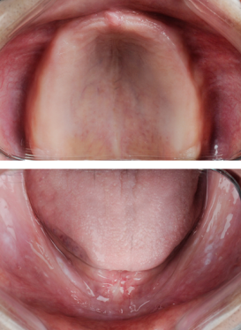

Figure2 Primary impression taken with impression compound.
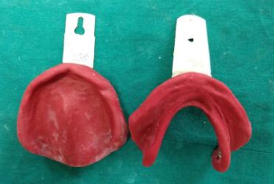

Figure3 Border moulding
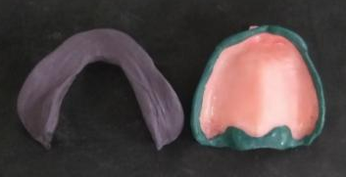

Figure 4 final impressions.
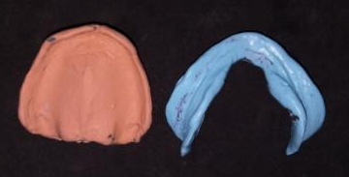

Figure5 Tentative jaw relations recorded
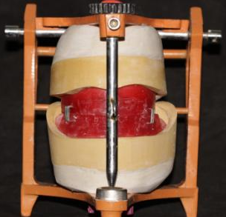

Figure 6 Three vertical stops of acrylic resin were
made on mandibular record base.
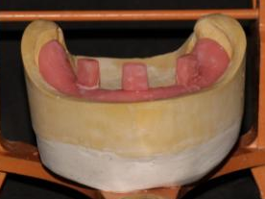

Figure7 Mandibular rim made with 3 part
green stick and 7 part impression compound.
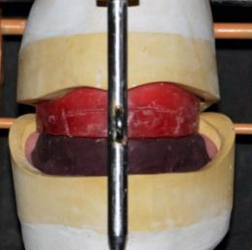

Figure8 Neutral zone recorded.
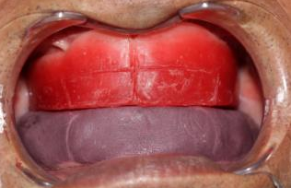

Figure9 Position of neutral zone recorded with putty index
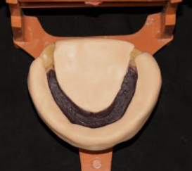

Figure10 Wax rim made in neutral zone region
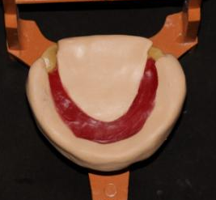

Figure11 Teeth arrangement done in neutral zone.
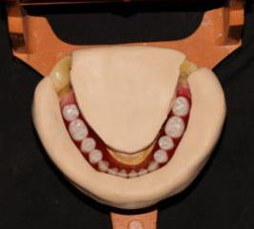

Figure12 Completed teeth arrangement
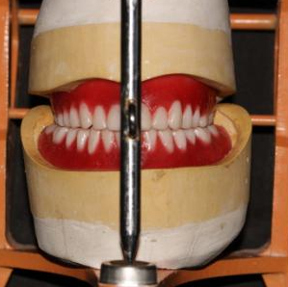

Figure13 Relined trial denture with zinc oxide eugenol paste
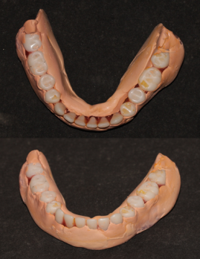

Figure14 Denture insertion
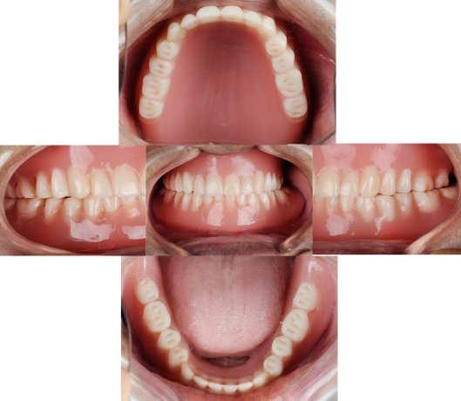

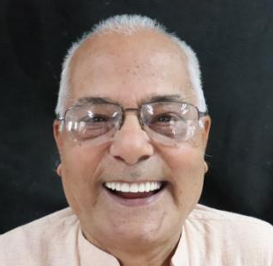
Figure15 Smile of satisfaction

Discussion:
The ultimate goal of any Prosthodontic treatment is to restore the form, function, and aesthetics of the patient. Simple impression procedures have been followed to get the maximum retention and stability of the complete denture, especially on the mandibular ridges. Providing stable mandibular dentures for patients with severely resorbed mandibular ridges is a challenge. One can overcome this problem if dentures are fabricated with their contours harmonizing neutral zone.²
Arranging artificial teeth within the neutral zone achieves two important objective: (1) prosthetic teeth do not interfere with normal muscle function; and (2) normal oral and perioral muscle activity imparts force against the complete dentures that serves to stabilize and retain the prosthesis rather than cause denture displacement. The neutral zone technique typically locates posterior denture teeth slightly facially, when compared to teeth arranged over the crest of the residual alveolar ridge.¹
Conclusion
The greater the residual alveolar ridge loss, the more important the neutral zone concept. With this technique the denture was found to have improved stability, retention and due to the adequate facial support, the overall appearance of the patient was esthetically pleasing. The masticatory performance was enhanced as compared to previous denture.

References:
- Cagna DR, Massad JJ, Schiesser FJ. The neutral zone revisited: from historical concepts to modern application. The Journal of prosthetic dentistry. 2009 Jun 1;101(6):405-12.
- Mageshwari M, Karunakar S, Rahul GR, Divya Hegde. Neutral zone concept for severely resorbed ridges- a clinical report. 2017 april:5(2);438-444.
- Singh NK, Lakshmana Rao Bathala DS. Neutral Zone in Complete Dentures.
- Yeh YL, Pan YH, Chen YY. Neutral zone approach to denture fabrication for a severe
mandibular ridge resorption patient: Systematic review and modern technique. Journal
of dental sciences. 2013 Dec 1;8(4):432-8.
- Beresin VE, Schiesser FJ. The neutral zone in complete dentures. The Journal of prosthetic dentistry. 1976 Oct 1;36(4):356-67.
- Beresin VE, Schiesser FJ. The neutral zone in complete dentures. Journal of Prosthetic Dentistry. 2006 Feb 1;95(2):93-100.
- Saravanakumar P, Thangarajan ST, Mani U. Improvised Neutral Zone Technique in a Completely Edentulous Patient with an Atrophic Mandibular Ridge and Neuromuscular Incoordination: A Clinical Tip. Cureus. 2017 Apr;9(4).
- Gahan MJ, Walmsley AD. The neutral zone impression revisited. British dental journal. 2005 Mar;198(5):269.
- Agarwal S, Gangadhar P, Ahmad N, Bhardwaj A. A simplified approach for recording neutral zone. The Journal of Indian Prosthodontic Society. 2010 Jun 1;10(2):102-4.
- Raja HZ, Saleem MN. Relationship of neutral zone and alveolar ridge with edentulous period. J Coll Physicians Surg Pak. 2010 Jun 1;20(6):395-9.

